COIT20268

**RESPONSIVE WEB DESIGN**

**Term-1, 2020**

**Portfolio 2 & Practical Assessment-2**

**Lecturer/Tutor:**

**Tom Marotta**

**Prepared By:**

**Bishal Budhathoki**

**12116421**

Table of Contents

Chapter 7 3

Chapter 8: 5

Standard Contributor Document: 7

Chapter 9 8

Chapter 10: 9

Chapter 11 10

Chapter 12 10

Review 1: 14

Review 2: 14

Review 3: 14

Review 4: 14

Feedback Result: 14

Assumptions: 15

Summary 15

# Chapter 7

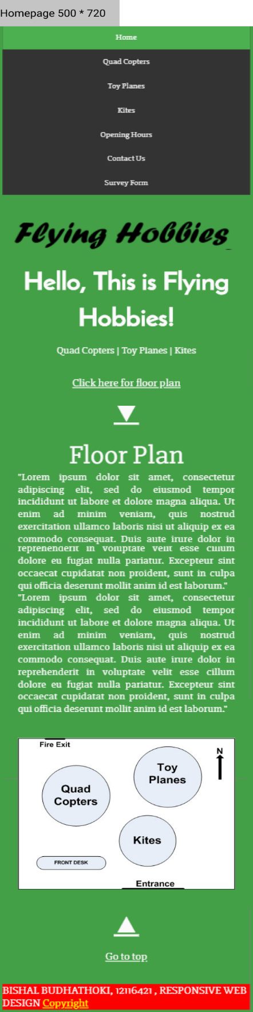Wireframe has been previously submitted in the assignment 1 and now its mockups are made considering both desktop and mobile view (500 * 720). These are designed using Figma tools.

Figure 1: Responsive Mobile View Mockup Home Page

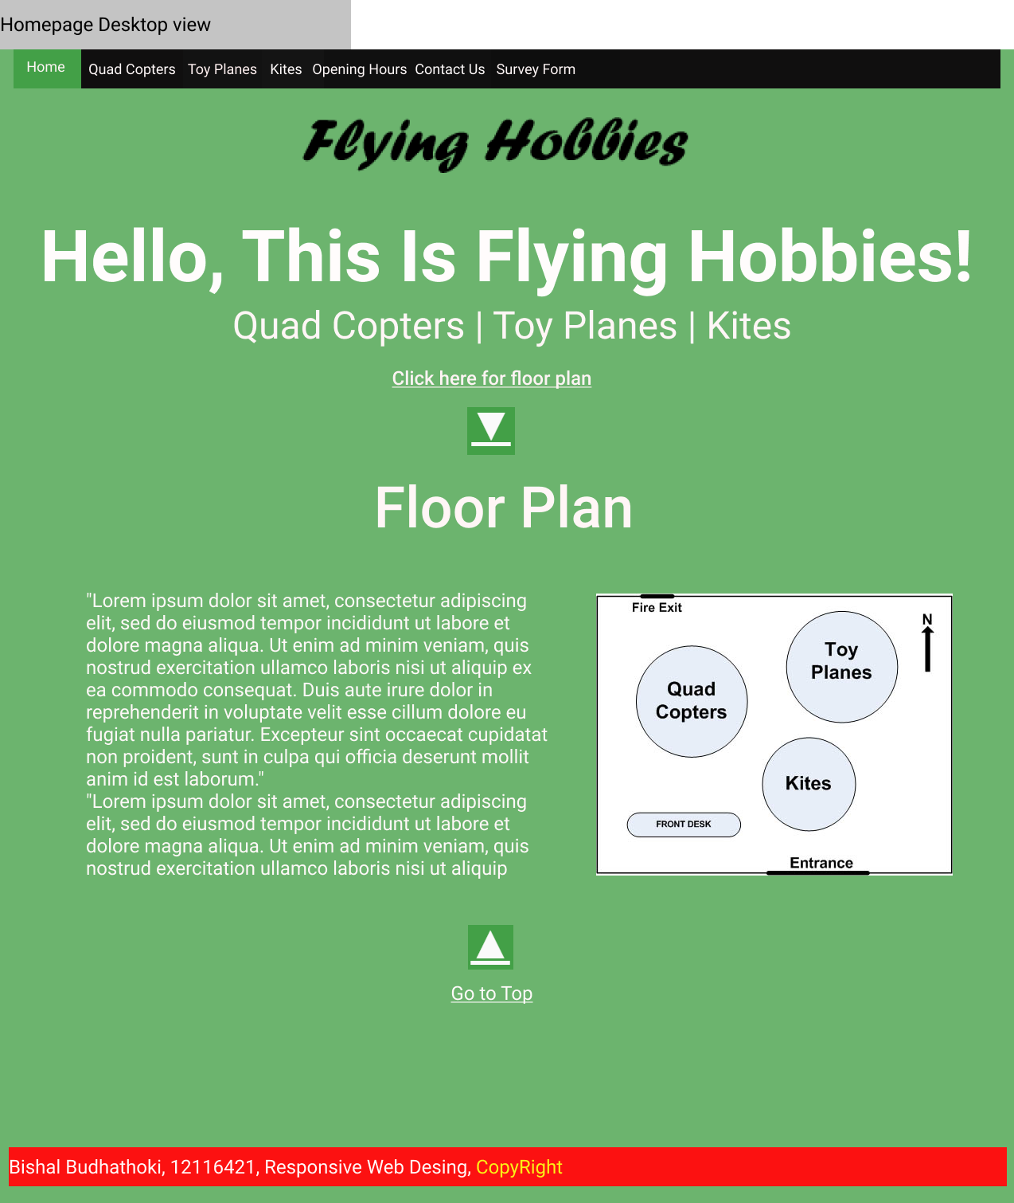

Figure 1: Responsive Desktop View Mockup of Home Page

# Chapter 8:

Here, only one external image is used along with provided image resource are used including html image code. Used image is the icon for the title tab.



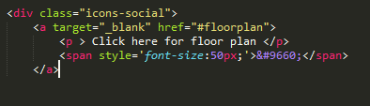Figure 3: This Is HTML coded icon and favicon used

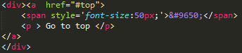

Figure 4: HTML coded icon which is &#9660 and &#9650

Color definitely helps portrait information in visual format and communicate as visual possible. For a situation say, font is white color and if a background is white or even near white like light grey then it is not properly visible or not visible.

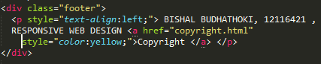For this assignment, most texts used here are plain white - #FAFAFA. For the copyright which has internal navigation link, it is highlighted in yellow. Background color is kind of green which is represented as #43A047.

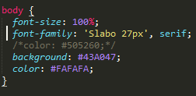

Figure 5: This is the text color used for body and footer

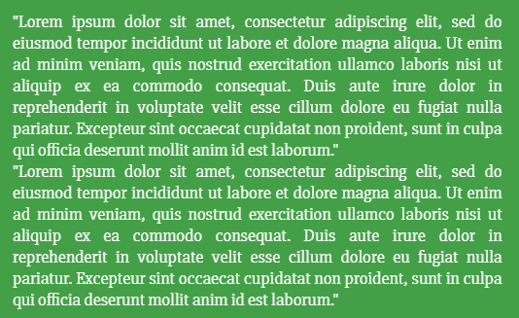Figure 6: Representation of body font color, footer highlight color and background theme color

For the navigation bar, while highlighting the specific tab, theme color is used but for other tab blackish color is used with color scheme #333.

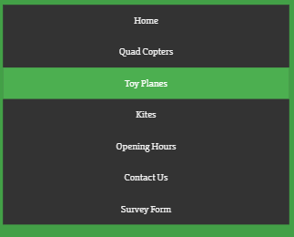

Figure 7: Navigation Bar color choice

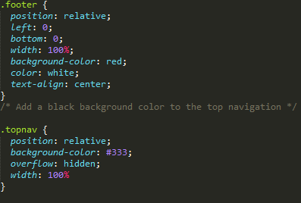For the navigation bar, logo and footer there is a standard property used. This includes spacing using padding, margins and more across all pages.

Figure 8: White spaces maintained using various properties

There are some image attributes that are not to be avoided while using it. This includes

src & alt.

Figure 9: Representing img attributes with attributes not to ignore

When moving from one page to another, color is used to denote the visited page/link. By default, home is highlighted with #43A047. When moving to next tab specific it will be highlighted with the same and remaining links will be #333 color. This is represented in Figure 7.

## Standard Contributor Document:

Following text can be used in the document for the contributors:

*For this portfolio, home page is index.html and their respective CSS properties are stored in CSS file stored in CSS folder, images contain fav icon, img contains all used images in their specific document and text files folder contain used text files for the portfolio.*

*Thank you for the contribution.*

# Chapter 9

Updated flowchart including internal and external navigation. External navigation takes us to <http://www.flyingobjects.com.au/>

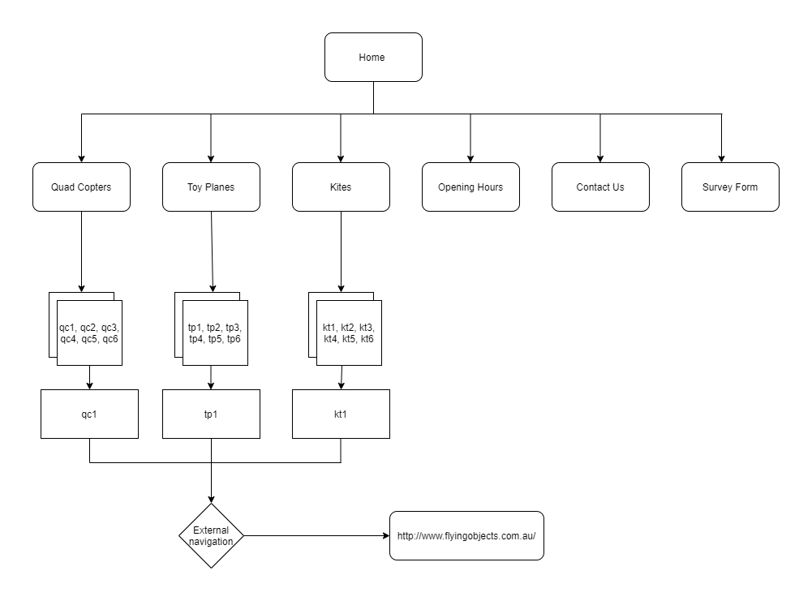

Figure 10: Flowchart of the website with internal and external navigation/link

# Chapter 10:

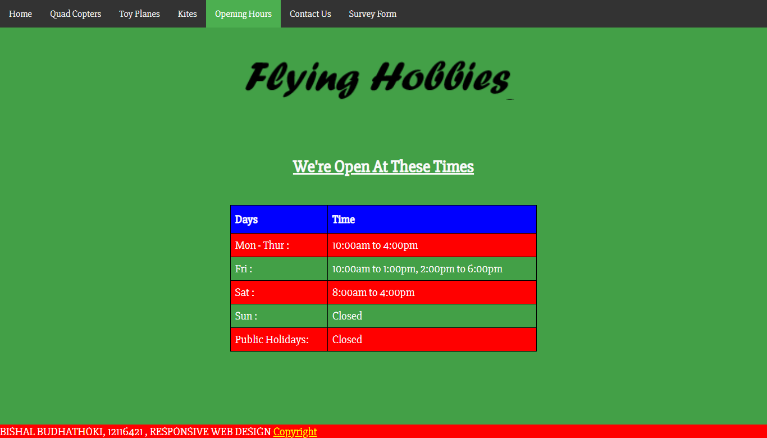

Figure 11: Business hours

Previously, the layout for business hour was different and not properly managed and this is the new layout for business hour in Openinghours.html file. Hover effect for every row and colorful layout using table is used.

# Chapter 11

This is the form to collect data like name, age, gender, their interest and some comments for anything they have in mind. There it is notified to the visitors that these data are only used for record purpose only.

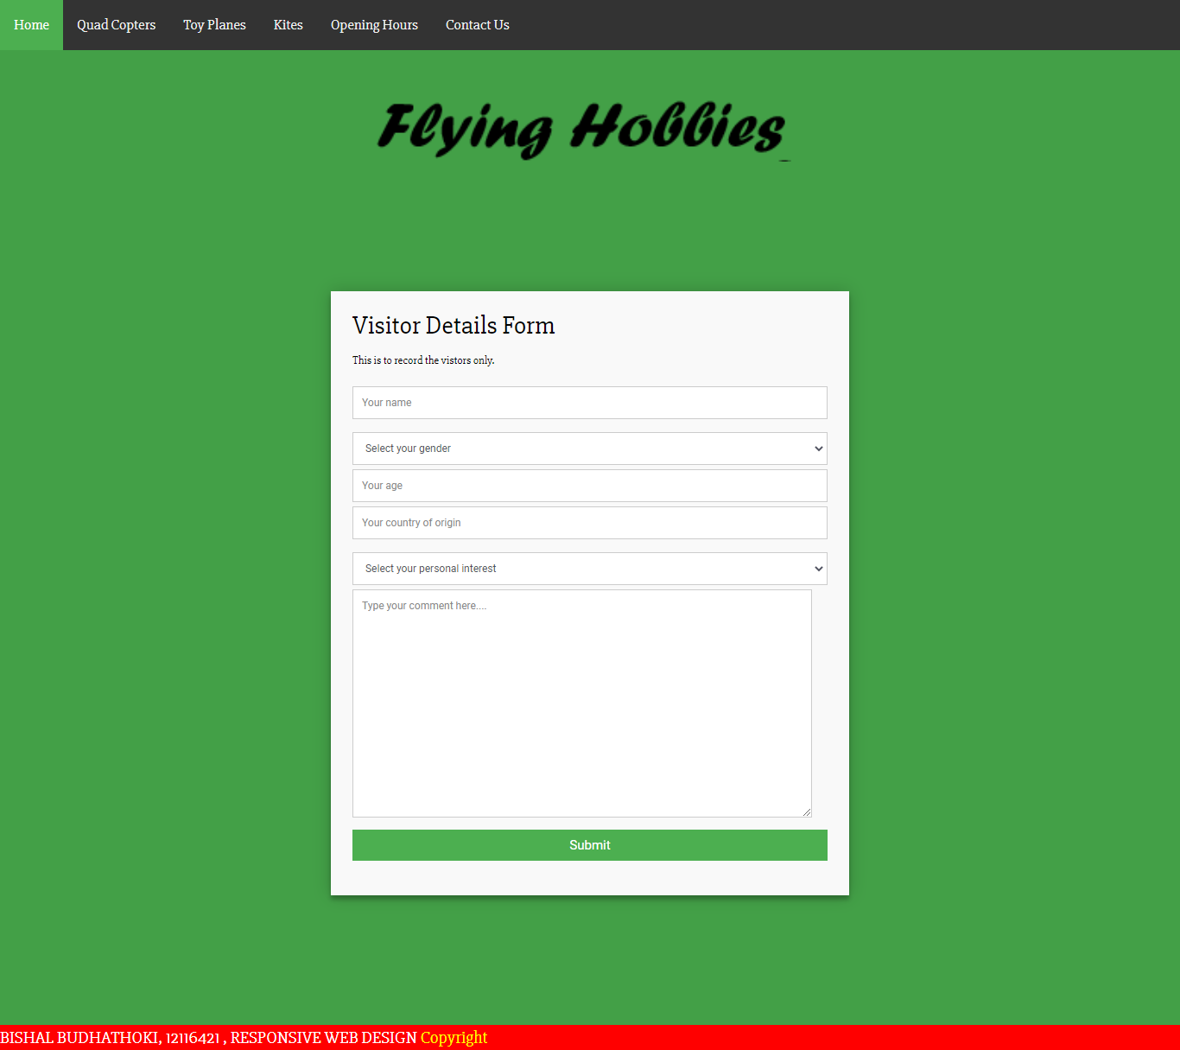

Figure 12: Visitor Detail Collection Form

# Chapter 12

Here for Chrome and Microsoft Edge is used to test the desktop version. For the mobile Samsung Galaxy Note 10 and iPhone is used. These both devices are obtained from Chrome Device Simulator. Here are some snapshots:

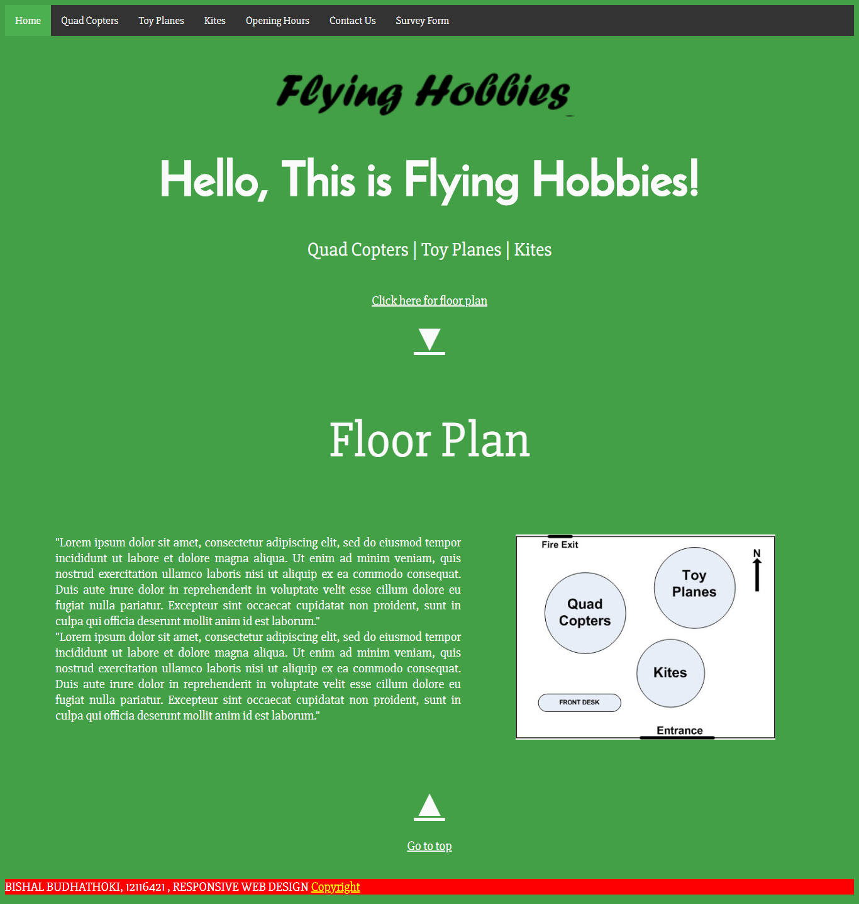

Figure 13: Screenshot obtained from both Chrome and Edge for desktop view of Home page

Figure 14: Screenshot obtained from both Chrome and Edge for desktop view for Opening hours / business hours

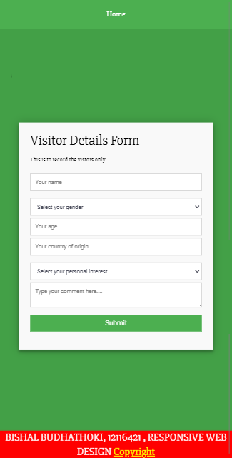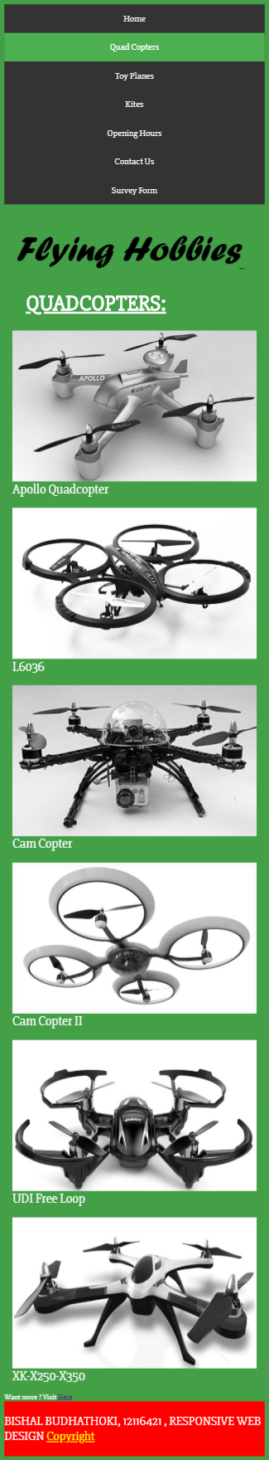

Figure 15: Screenshot obtained from both mobile devices from Chrome Device Simulator

## Review 1:

Reviewer: Bipin Dotel

Appealing to layman as it has simple layout and also highly effective. Layout is clean, smooth and if someone has no technical background can also understand to use this website. As every content is well positioned looks professional.

Color scheme used is pleasing to the eyes.

Recommendation: If more images on product sites then the gallery would look more attractive.

## Review 2:

Reviewer: Kush Shrestha

* Easy to navigate
* Highlighting the tab is helpful to know where user is
* Form used is simple and understandable.
* Website looks simple and easy to use.

Recommendation: Use of latest technology would make it more colorful, vibrant and functional.

## Review 3:

Reviewer: Riwaj

Design seems consistent in all pages using of limited but pleasing to the eye color makes it attractive. Greenish color background, white text, black like navigation bar is interesting. Information are well placed even in mobile view.

Web pages are responsive enough.

Recommendation: Consider supporting all possible screen and may be use of banner is great.

## Review 4:

Reviewer: Sam Radcliff

Simple UI, appealing to average people and understandable contents. Due to limited graphics, loading is fast and support of minimal screen size with being responsiveness makes it modern. Flow is smooth and well maintained.

Recommendation: Should have alternate to graphics for navigation if some device does not support. Link text size if more would make it easy to use.

## Feedback Result:

* Including more graphics could help.
* Alternative navigation if loading navigation graphics would be beneficial.
* Supporting left over screen size can be an advantage.

## Assumptions:

1. Only 6 devices/toys are sold in this website and if more needed there is external link to another website.
2. For mobile device in ContactUsForm.html, link to home page is only available for navigation bar assuming for itself is huge and more nav-bar content make it lengthier.

Users felt like having more items in the product gallery and felt like having in house rather than external link.

# Summary

By making improvements on Portfolio 1, this report and the website is prepared. This website supports mobile device of screen size 500 * 720 pixels and desktop ranging from 1024 * 768 to 1280 * 1024 pixels. Website is made responsive with the landscape mode also. From the previous wireframe made, its mock-ups design is made using Figma. Various color standard, white spaces standard, img attribute and their standard with color link to the links are well developed. Contributors documentation is prepared. Latest flowchart with internal and external links is prepared. Business hours is well presented in table format. It is made colorful. Form to collect visitor information is also prepared and all the web pages are tested in desktop browsers and simulated mobile devices for responsiveness and support of various screen size device. Reviews for the website are also obtained from 4 different persons and their recommendations are analyzed along with the assumptions made.